

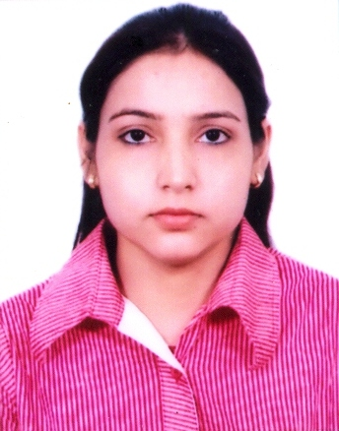

Name : Aarti Kumari

Gender : Female

Age : 25 Years.

Date of Birth : 08-06-1990 Father’s Name : Pyare Lal

Area of Residence : Moh- Katra brahampur, near, near razi chowk,

shiv mandir ke paas, Badaun 243601

Email id : [tichsagar@yahoo.com](mailto:tichsagar@yahoo.com)

# PGDBM with TimesPro

**Completed Post Graduate Diploma in Banking Management PGDBM**

Centre Name : Times Centre for Learning Limited (Times Pro, Lucknow). Registration Number : E14CC1017891

Batch Code : LUC01AA1015

# Academic Scores

|  |  |
| --- | --- |
| **Subject** | **% Marks Obtained** |
| Introduction to Banking | 76 |
| Law and Practice of Banking | 64 |
| Retail Banking | 64 |
| Business Banking | 64 |
| NRI Banking | 80 |
| Wealth Management and Financial Planning | 78 |
| New Age Banking | 80 |
| Core Banking Solution ( Finacle) | 72 |
| Management of Banks | 76 |
| Communication Skills | 61 |
| Accounting and Financial Mathematics for Bankers | 56 |
| Sales and Relationship Management | 65 |
| Essentials of Customer Service | 77 |
| Business Intelligence | 75 |
| Economic Times FinPro  GDP, Business Cycles, Inflation, Interest Rates, Monetary Policy, Fiscal Policy, Mutual Funds and Hedge Funds, PPF, NSC, POMIS, RGESS, NPS, Investor Life Cycle, Financial Goals, Saving Pattern changes, Income Tax, Capital Gains Tax, Dividend Distribution Tax for MFs | M-1=63  M-2=55  M-3=55  M-4=65  M-5=64  M-6=65 |



**Academic Credentials**

|  |  |  |  |  |  |
| --- | --- | --- | --- | --- | --- |
| **Qualification** | **Year of Passing** | | **School/College** | **Board/University** | **Percentage** |
| **Xth** | | 2007 | P.A.K. Inter College Badaun | U.P. Board Allahabad | 49.33% |
| **XIIth** | | 2009 | P.A.K. Inter College Badaun | U.P. Board Allahabad | 56.00% |
| **Graduation** | | 2012 | N.M.S.M. Das Mahavidyalaya Badaun | M.J.P.R.U. University Bareilly | 52.58% |
| **Post Graduation** | | 2014 | N.M.S.M. Das Mahavidyalaya Badaun | M.J.P.R.U. University Bareilly | 60.44% |

**Certifications/Achievements:**

* Diploma in computer application

# Work Experience

|  |  |  |  |  |
| --- | --- | --- | --- | --- |
| **From** | **To** | **Organization** | **Designation** | **Profile** |
|  |  |  |  |  |
|  |  |  |  |  |

I hereby declare that all the above statements are true and complete to the best of my knowledge.

Date:

Place: Lucknow (Aarti Kumari)